**Spring REST using Spring Boot 3**

**Exercise 1:Hello World RESTful Web Service**

1. Open your spring-learn project

2. Change the Port to 8083

|  |
| --- |
| application.properties  spring.application.name=spring-learn  server.port=8083 |

3. Create Controller Class

|  |
| --- |
| HelloController.java  package com.cognizant.spring_learn.controller;  import org.slf4j.Logger;  import org.slf4j.LoggerFactory;  import org.springframework.web.bind.annotation.GetMapping;  import org.springframework.web.bind.annotation.RestController;  @RestController  public class HelloController {  private static final Logger LOGGER = LoggerFactory.getLogger(HelloController.class);      @GetMapping("/hello")      public String sayHello() {          LOGGER.info("START: sayHello()");          String message = "Hello World!!";          LOGGER.info("END: sayHello()");          return message;      }  } |

**Output:**

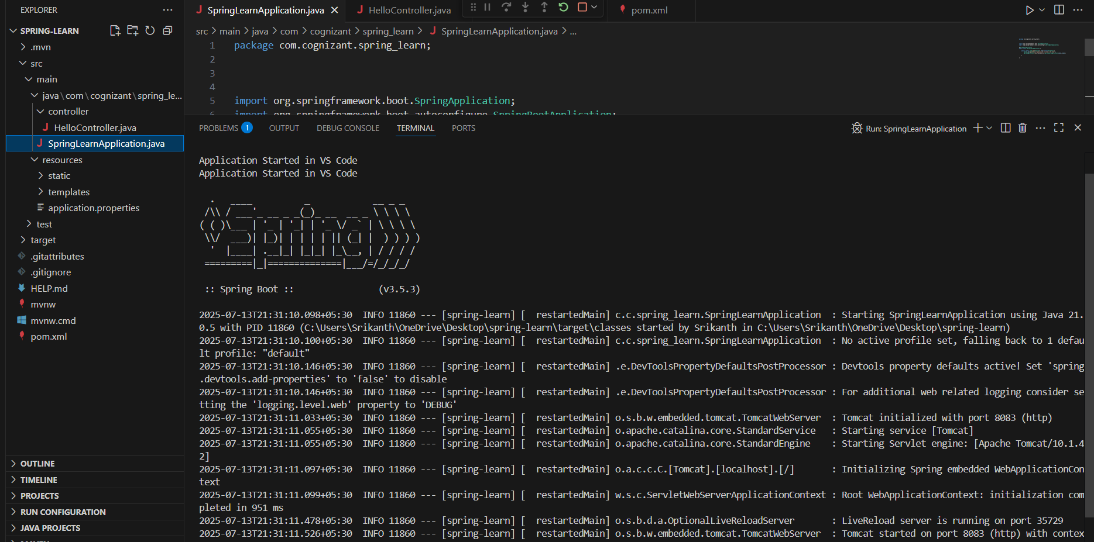

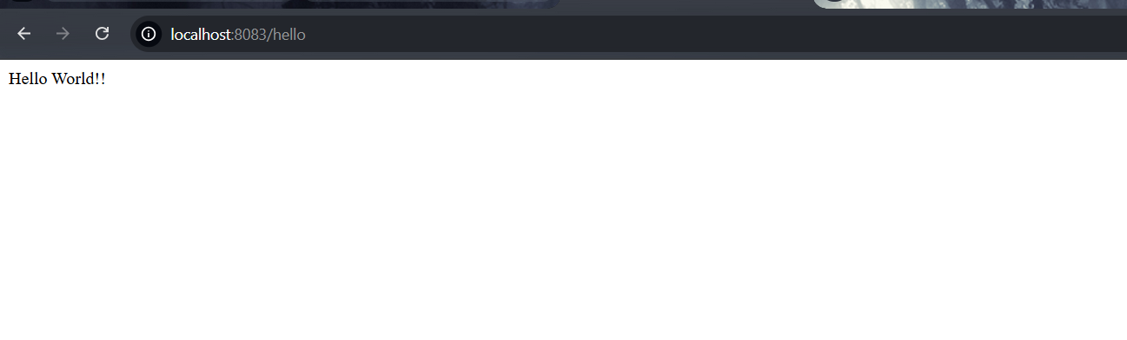

**Exercise 2: REST - Country Web Service**

1.Create the Country Java Class

|  |
| --- |
| Country.java  package com.cognizant.spring_learn;  public class Country {  private String code;      private String name;        public Country() {}      public String getCode() {          return code;      }      public void setCode(String code) {          this.code = code;      }      public String getName() {          return name;      }      public void setName(String name) {          this.name = name;      }  } |

2. Define the Country Bean in XML

|  |
| --- |
| Country.xml  <?xml version="1.0" encoding="UTF-8"?>  <beans xmlns="http://www.springframework.org/schema/beans"         xmlns:xsi="http://www.w3.org/2001/XMLSchema-instance"         xsi:schemaLocation="http://www.springframework.org/schema/beans                             https://www.springframework.org/schema/beans/spring-beans.xsd">      <bean id="country" class="com.cognizant.spring_learn.Country">          <property name="code" value="IN" />          <property name="name" value="India" />      </bean>  </beans> |

3. Create the Controller Class

|  |
| --- |
| CountryController.java  package com.cognizant.spring_learn.controller;  import org.slf4j.Logger;  import org.slf4j.LoggerFactory;  import org.springframework.context.ApplicationContext;  import org.springframework.context.support.ClassPathXmlApplicationContext;  import org.springframework.web.bind.annotation.RequestMapping;  import org.springframework.web.bind.annotation.RestController;  import com.cognizant.spring_learn.Country;  @RestController  public class CountryController {   private static final Logger LOGGER = LoggerFactory.getLogger(CountryController.class);      @RequestMapping("/country")      public Country getCountryIndia() {          LOGGER.info("START: getCountryIndia()");          ApplicationContext context = new ClassPathXmlApplicationContext("country.xml");          Country india = context.getBean("country", Country.class);          LOGGER.info("END: getCountryIndia()");          return india;      }  } |

**Output:**

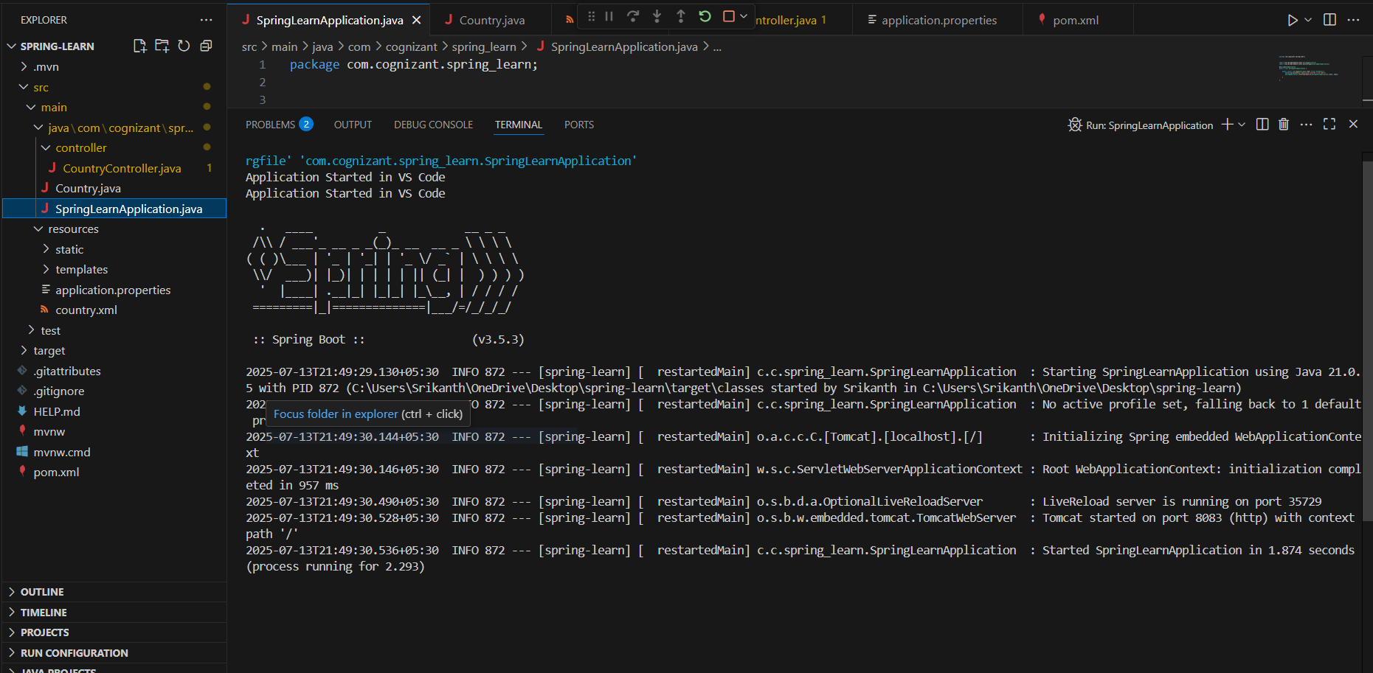

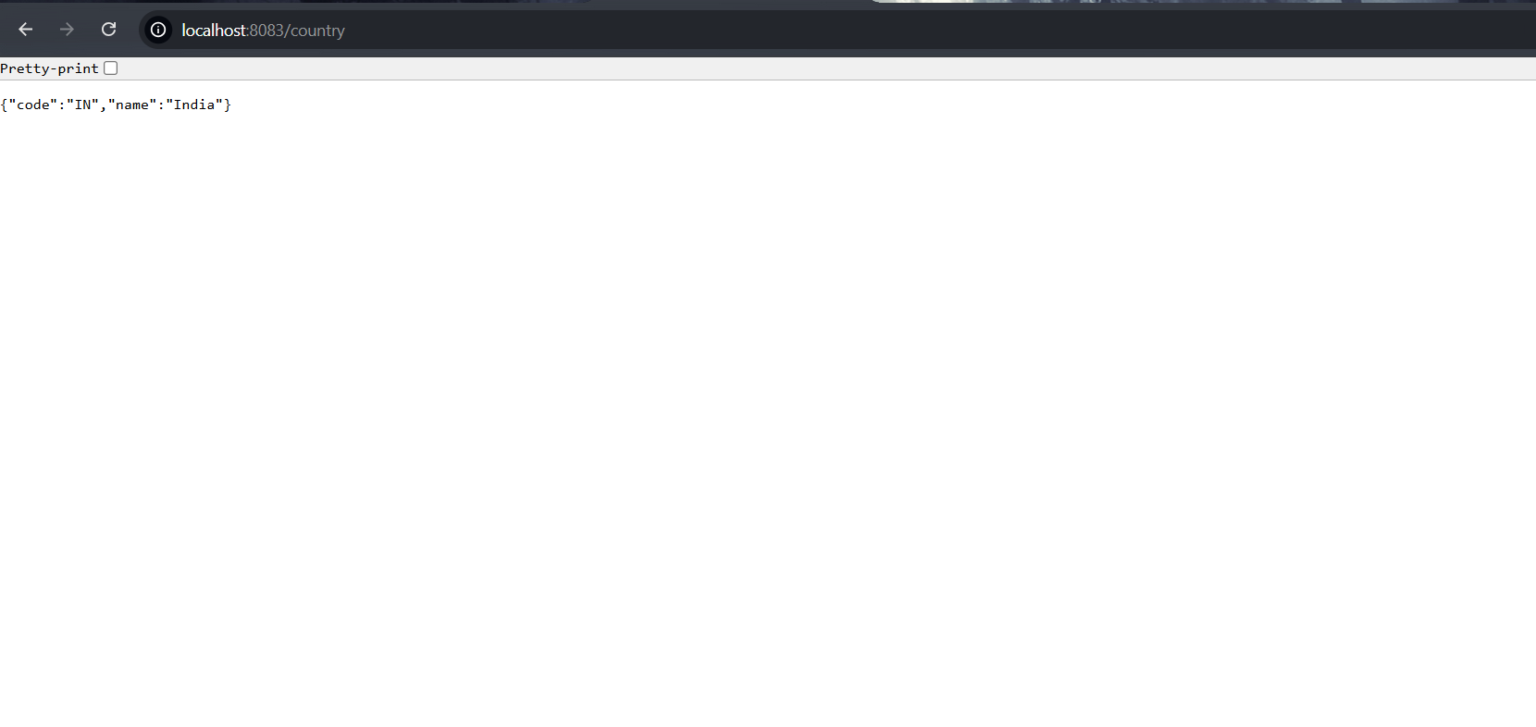**Exercise 3:** **REST - Get country based on country code**

1.Create country.java

|  |
| --- |
| country.java  package com.cognizant.spring_learn;  public class Country {  private String code;      private String name;        public Country() {}      public String getCode() {          return code;      }      public void setCode(String code) {          this.code = code;      }      public String getName() {          return name;      }      public void setName(String name) {          this.name = name;      }  } |

2. Update country.xml

|  |
| --- |
| <?xml version="1.0" encoding="UTF-8"?>  <beans xmlns="http://www.springframework.org/schema/beans"         xmlns:xsi="http://www.w3.org/2001/XMLSchema-instance"         xsi:schemaLocation="http://www.springframework.org/schema/beans                             https://www.springframework.org/schema/beans/spring-beans.xsd">      <bean id="country" class="com.cognizant.spring_learn.Country">          <property name="code" value="IN"/>          <property name="name" value="India"/>      </bean>      <bean id="countryList" class="java.util.ArrayList">          <constructor-arg>              <list>                  <bean class="com.cognizant.spring_learn.Country">                      <property name="code" value="IN"/>                      <property name="name" value="India"/>                  </bean>                  <bean class="com.cognizant.spring_learn.Country">                      <property name="code" value="US"/>                      <property name="name" value="United States"/>                  </bean>                  <bean class="com.cognizant.spring_learn.Country">                      <property name="code" value="CN"/>                      <property name="name" value="China"/>                  </bean>              </list>          </constructor-arg>      </bean>  </beans> |

3. Create CountryService

|  |
| --- |
| package com.cognizant.spring_learn.service;  import java.util.List;  import org.springframework.context.ApplicationContext;  import org.springframework.context.support.ClassPathXmlApplicationContext;  import org.springframework.stereotype.Service;  import com.cognizant.spring_learn.Country;  @Service  public class CountryService {      public Country getCountry(String code) {          ApplicationContext context = new ClassPathXmlApplicationContext("country.xml");          List<Country> countries = (List<Country>) context.getBean("countryList");          return countries.stream()                  .filter(country -> country.getCode().equalsIgnoreCase(code))                  .findFirst()                  .orElse(null);      }  } |

4. Create CountryController

|  |
| --- |
| package com.cognizant.spring_learn.controller;  import org.slf4j.Logger;  import org.slf4j.LoggerFactory;  import org.springframework.beans.factory.annotation.Autowired;  import org.springframework.web.bind.annotation.GetMapping;  import org.springframework.web.bind.annotation.PathVariable;  import org.springframework.web.bind.annotation.RestController;  import com.cognizant.spring_learn.Country;  import com.cognizant.spring_learn.service.CountryService;  @RestController  public class CountryController {      private static final Logger LOGGER = LoggerFactory.getLogger(CountryController.class);      @Autowired      private CountryService countryService;      @GetMapping("/countries/{code}")      public Country getCountry(@PathVariable String code) throws Exception {          LOGGER.info("START: getCountry()");          Country country = countryService.getCountry(code);          LOGGER.info("END: getCountry()");          return country;      }  } |

**Output:**

